**PROBLEM SOLUTION FIT**

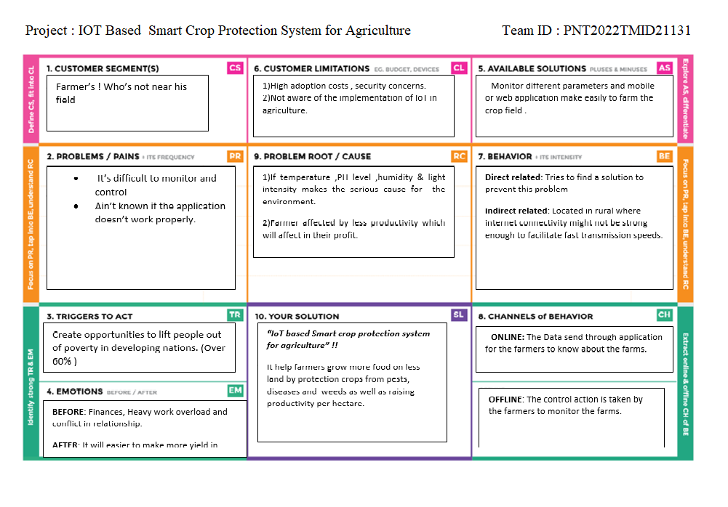 It tells about the solution for existing issue which can be elaborately implemented and applied in the resultant progress of the project.